IIT Tutorial 2 Week 3 (Problem Solving Process Practice)

Terms:
- Combinational Logic Circuit:
- memoryless digital circuits where the output depends solely on the present, immediate input combination. Comprised of basic logic gates (AND, OR, NOT, NAND, NOR).

Part 1: The Challenge
- Create a combinational logic circuit that operates an alarm in a car whenever the driver and/or passenger seats are occupied, and the seatbelts are not fastened when the car is started.

- The active-HIGH signals DRIV and PASS indicate the presence of the driver and passenger, respectively, and are taken from pressure-actuated switches in the seats.

- The signal IGN is active-HIGH when the ignition switch is on. The signal 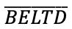 is active-LOW and indicates that the driver’s seatbelt is unfastened. 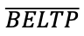 is the corresponding signal for the passenger seatbelt.

- The alarm will be activated (LOW) whenever the car is started and either of the front seats is occupied and its seatbelt Is not fastened.

- My goal is to design the logic needed to fulfill the above conditions, using the problem-solving process (PSP) taught during the lectures alongside the Boolean design process (BDP). Below is a step-by-step guide to assist you in this endeavour.

Part 2: The Problem Solving Process
Step 1: Understand and Define the Problem (Analyse)

(Rewrite the Problem in my own words – one paragraph)
- Our challenge is to develop a combinational logic circuit, which triggers an alarm whenever the passengers and driver of a vehicle 1. Are occupying a seat within the car, 2. have not fastened their seatbelts, and 3. with the car being turned on through the ignition switch.

(This can also be done through dot-points)
- Driver / Passenger Seat is occupied seat belt(s) aren’t fastened
- Ignition is ON

Step 2: Organise and Describe the Data
- Inputs:
  - Logic (Active-HIGH signal (If driver is in the seat, then DRIV 1))
    - DRIV Driver
    - PASS Passenger
  - Logic (Active-HIGH signal (When the ignition switch is on IGN 1))
    - IGN Ignition
  - Logic (Active-LOW signal (When the drivers’ / passengers seatbelt is unfastened, then -(BELTD / P)- 0))
    - -(BELTD)- (*Indicates Bar) – Driver’s Belt
    - -(BELTP)- Passenger’s Belt
- Outputs:
  - Logic (Active-LOW signal (Whenever the car is started and either of the front seats is occupied and its seatbelt Is not fastened, then –(ALARM)- 0)
  - –(ALARM)- Seatbelt Alarm

Symbol | Description | Type | Example
DRIV | Drivers’ seat pressure plate – indicating presence of driver. | INPUT | HIGH(1 = Occupied)
PASS | Passenger(s) seat pressure plate – Indicating presence of passenger(s). | INPUT | HIGH(1 = Occupied)
IGN | Ignition Switch Sensor – indicates whether ignition switch is on / car is on. | INPUT | HIGH(1 = Vehicle On)
~BELTD | Drivers’ seat seatbelt sensor – indicating whether driver has seatbelt on. | INPUT | LOW(0 = Belt Off)
~BELTP | Passenger seat seatbelt sensor – indicating whether driver has seatbelt on. | INPUT | LOW(0 = Belt Off)
~ALARM | Alarm – An alarm triggered whenever its conditions are meet. | OUTPUT | LOW(0 = ON)

Step 3: Plan the Solution (Design the Algorithm)

3.1 Algorithm (in plain English) (Change Algorithm, Initially Incorrect – Update Corresponding to Truth table) – Check whether Driver is there, then check passenger seats.
Start
Check Sensors (DRIV, PASS, IGN, ~BELTD, ~BELTP)

IGN = 1 (Ignition is on)

Driver is seated and driver’s seatbelt is not fastened. DRIV = 1 and ~BELTD = 0 (DRIV =1 ^ ~BELTD = 0)

Passenger is seated and Passenger’s seatbelt is not fastened. PASS = 1 and ~BELTP = 0

If either of the conditions above are TRUE, then the alarm will turn ON.

Otherwise, the alarm should be OFF.

3.2 Truth Table
- Include all inputs and outputs in the truth table.

DRIV | PASS | ~BELTD | ~BELTP | IGN | ~ALARM
0 | 0 | 0 | 0 | 1 | 1
0 | 0 | 0 | 1 | 1 | 1
0 | 0 | 1 | 0 | 1 | 1
0 | 0 | 1 | 1 | 1 | 1
0 | 1 | 0 | 0 | 1 | 1
0 | 1 | 0 | 1 | 1 | 1
0 | 1 | 1 | 0 | 1 | 1
0 | 1 | 1 | 1 | 1 | 1
1 | 0 | 0 | 0 | 1 | 0
1 | 0 | 0 | 1 | 1 | 0
1 | 0 | 1 | 0 | 1 | 1
1 | 0 | 1 | 1 | 1 | 1
1 | 1 | 0 | 0 | 1 | 0
1 | 1 | 0 | 1 | 1 | 0
1 | 1 | 1 | 0 | 1 | 0
1 | 1 | 1 | 1 | 1 | 1

3.3 Boolean Expressions (SOP) (Sum of Product)
$$DRIV.\overline{PASS}.\overline{BELTD}.\overline{BELTP}.IGN$$
$$DRIV.\overline{PASS}.\overline{BELTD}.BELTP.IGN$$
$$DRIV.PASS.\overline{BELTD}.\overline{BELTP}.IGN$$
$$DRIV.PASS.\overline{BELTD}.BELTP.IGN$$
$$DRIV.PASS.BELTD.BELTP.IGN$$

- $\overline{ALARM}= DRIV.\overline{PASS}.\overline{BELTD}.\overline{BELTP}.IGN+ DRIV.\overline{PASS}.\overline{BELTD}.BELTP.IGN+ DRIV.PASS.\overline{BELTD}.\overline{BELTP}.IGN+ DRIV.PASS.\overline{BELTD}.BELTP.IGN+ DRIV.PASS.BELTD.BELTP.IGN$

3.4 Flowchart
- 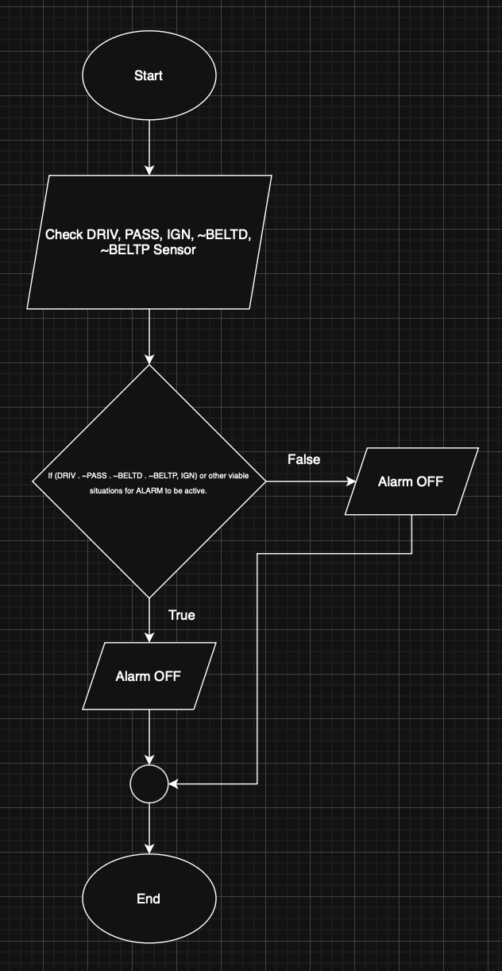
3.5 Pseudocode
- IF
($\overline{ALARM}= DRIV.\overline{PASS}.\overline{BELTD}.\overline{BELTP}.IGN OR DRIV.\overline{PASS}.\overline{BELTD}.BELTP.IGN OR$
$$DRIV.PASS.\overline{BELTD}.\overline{BELTP}.IGN OR DRIV.PASS.\overline{BELTD}.BELTP.IGN OR$$
$DRIV.PASS.BELTD.BELTP.IGN$)

ALARM = 0
ELSE
ALARM = 1
END
Step 4: Test and Refine the Solution (Debug and Verify)
- Provide test scenarios and verify whether the solution implemented would be effective.

DRIV | PASS | ~BELTD | ~BELTP | IGN | ~ALARM
0 | 1 | 1 | 1 | 1 | 1
1 | 0 | 0 | 0 | 1 | 0
1 | 0 | 0 | 1 | 1 | 0
1 | 0 | 1 | 0 | 1 | 1
1 | 0 | 1 | 1 | 1 | 1
1 | 1 | 0 | 0 | 1 | 0
1 | 1 | 0 | 1 | 1 | 0
1 | 1 | 1 | 0 | 1 | 0
1 | 1 | 1 | 1 | 1 | 1
- If the passenger is in the car and their belt is on, but the driver is not the alarm will not be active.
- If the driver is in the car and their belt isn’t on, and the ignition is on the alarm will be active.

Part 3: Implementing the Solution
- Using the app logic circuit to develop a simulation.
